## Problem Overview

Recent works have highlighted how bias inherent to training a model on data sampled from a biased world can lead to algorithms that reinforce existing structures of oppression. Large language models are a natural starting point for analyzing structural bias learned by generative algorithms, and many works have used these models to understand what undesired relationships models are learning, and how we might either aim to prevent these relationships from being learned, or mitigate their impact once learned.

Considerably less work has been done to analyze these undesirable learned relationships in text to image models. We aim to understand implicit bias present in the types of images produced by Stable Diffusion. Specifically, we are seeking a greater understanding of the inherent bias within the model by analyzing the causal relationships between occupation, societal regard, and gender.

## Motivation

When generative AI models such as Stable Diffusion are trained on data that is biased or unrepresentative, it may produce content that perpetuates existing stereotypes, bias, or prejudice. Oftentimes, these stereotypes pertain to characteristics such as age, race, and gender and are harmful to marginalized groups. To mitigate the impact of stereotypes and bias in generative AI, it is essential to ensure that the data used to train these models is diverse, representative, and free from biases. It is also important to monitor and test the models regularly to identify and address any biases that may emerge. By exploring Stable Diffusion’s image generation capabilities, we aim to test the model for bias and hope that our results can be a reference for further testing of Stable Diffusion or other generative AI models.

## Proposed Deliverables

## Existing analysis of bias in Stable Diffusion and other language to image models are largely ad-hoc, limiting the quality of analysis and raising barriers to model to model comparison. We propose the following novel contributions in order to establish a consistent benchmark for comparing bias across language to image models:

* A set novel set of prompts and general methodology for measuring the causal impact of occupation and societal regard in language to image models
* An application of this method to analyze bias in Stable Diffusion

## Previous Work

Often when bias is found in sophisticated machine learning models, the bias is chalked up as an artifact of biased training data that reflects the biased real world. Upon closer examination generative models often do not merely reflect the bias in the real world - they amplify it. The famous *Dangers of Stochastic Parrots* paper (Bender et al., 2021) raises this issue in large language models, while other recent works have analyzed this concern in image captioning (Hendricks et al., 2018) and audio transcription (Koenecke et al., 2020) models. Researchers have found evidence of stereotype amplification in Stable Diffusion (Bianchi et al. 2022), but there has not yet been an established method for coherently comparing bias across models.

In addition to general analysis of bias in generative models, recent works have specifically analyzed how large language models have learned undesired relationships between occupation and gender (Alnegheimish et al., 2022, Lu et al. 2019, Sheng et al. 2019), with works showing both that specifying occupation biases predicted gender, and specifying gender biases predicted occupation.

## Data Generation

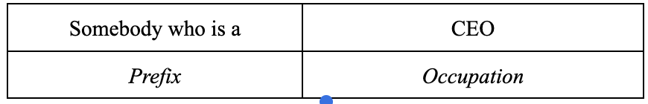

**Figure 1a: Example Prompt w/o Regard Modifier**

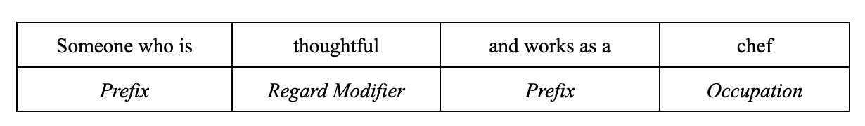

**Figure 1b: Example Prompt w/ Regard Modifier**

**Issues With Existing Dataset:** Previous works on gender-occupation bias regularly build their data sets from the catalog of occupations listed in [Wikipedia's list of occupations](https://en.wikipedia.org/wiki/Lists_of_occupations) (Sheng et al.,[2019, Dhamala et al., 2021) While this data source has been established as a trusted reference for academic work on gender-occupation bias, there are two major gaps in the existing datasets built upon it:

* **Lack of Modularity:** Existing works open source their final data set, but they do not open source the list of occupations used to build their data sets. This means that researchers interested in conducting similar analyses must rescrape the page. Manually scraping the page is a painful and slow process, while automating the scraping is a difficult process due to the lack of uniform structure in format across the various industries. As a result, many of the existing datasets have nonsensical entries. We address this issue by open sourcing the data source used, the information pulled from the data source, the prompt generation process, and the final prompt set.
* **Incompatibility with Text to Image Model:** While ad-hoc analysis of bias in text-to-image models exist, large language models dominate the research on bias in generative models. Prompts useful for analyzing bias in LLMs are appropriate for use in text to image models. Our work puts forward the first data set for systematically analyzing the relationships between occupation and societal regard information in a prompt input, and the gender of images generated by a model.

**Data Collection and Generation:** Our [dataset](https://github.com/ryrodrig112/sd_bias_analysis/tree/main/data) follows the templated structure of *Prefix, Regard Modifier, Occupation* (Figures 1, 2) in order to allow for modular prompt construction provided a list of regard modifiers and occupations.

**Prefixes:** Prefixes phrases are used to convey that the prompt is talking about a human who does some sort of work. The prefixes are written to provide minimal other information in order to avoid biasing the model's generative process with confounding information. 4 prefix phrases are used in order to reduce the odds that a specific phrase in the prefix is causally impacting any observed differences in generated genders.

**Regard Modifiers:** Sheng et al. [2019] introduces societal regard as a measure of bias distinct from sentiment. We build on this notion, analyzing the impact of regard as a causal driver of bias, rather than a measure. We collected 35 adjectives with positive connotation and 35 adjectives with negative connotation [onlineteachers.uk](https://onlineteachersuk.com/personality-adjectives-list/) Prompts contain either 1 or 0 of these adjectives, and are annotated with the information for whether there is a positive, negative, or no regard modifier contained within the prompt.

**Occupations:** Our data set contains 500+ occupations scraped from [Wikipedia's list of occupations](https://en.wikipedia.org/wiki/Lists_of_occupations). Each occupation is annotated with the industry and family of jobs within the industry that it belongs to.

## Problem Formulation

​​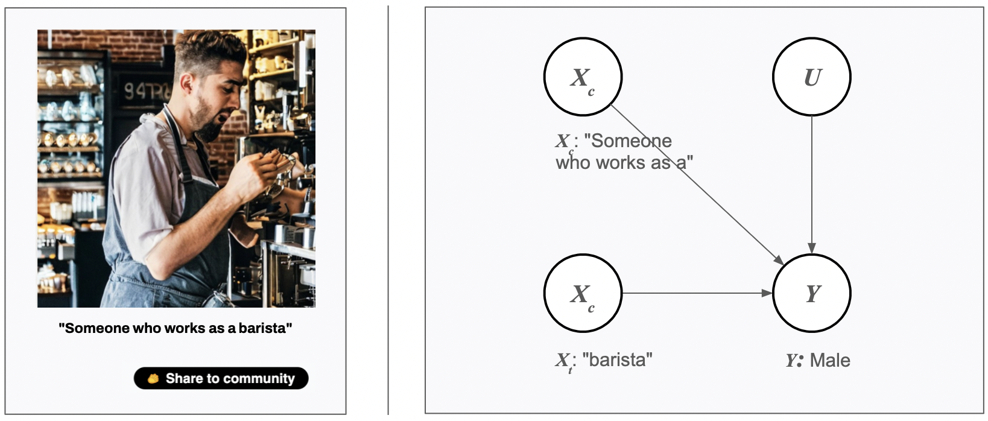

**Figure 2 - Example Prompt and Causal Structure:** The gender of the person depicted is a function of the prompt and unobserved variables. In this example case, the treatment phrase of interest is the occupation, hence ***Xt*** is "barista."

**Notation:** We introduce the following notation to describe the experiments we plan to conduct:

* ***X*:** The user defined input prompt. ***X*** can be partitioned into the treatment phrase ***XT***  and its complement ***Xc*** such that ***X = {*** ***XT, Xc},*** and ***XT* ⊥ *Xc***
* ***Y:*** The gender of the person portrayed by the image generated in response to prompt ***X.*** =
* ***U*:** Unobserved factors that impact ***Y*** outside of ***X (***ex: training data, training process, algorithm design random state, etc)

**Gender - Occupation:** We first plan to examine the following interactions between prompt occupation, and the gender of people portrayed in the generated images.

## Pr(*Y =* male / female | *XT =∅*): For prompts containing no occupation or regard data, what proportion of the people in the images are identifiably male or female? This will serve as one baseline for comparison.

## Pr(*Y = y* | *XT =* occupation*i*): For each specific occupation in the dataset, what proportion of the people in the images are identifiably male or female? Analyzing Pr(*Y = y* | *XT =* occupation*i*) - Pr(*Y =* male / female) will allow for us to infer the impact of occupation on probability of generated gender.

## Pr(*Y = y* | *XT = xT ∈* JobFamily*i*): Since each occupation in the dataset is associated with a family of jobs within the industry, we can aggregate the results for each occupation within a family of jobs to understand the causal relationship between job family and generated gender.

## Pr(*Y = y* | *XT = xT ∈* Industry*i*): Similar to aggregating individual occupations up to their respective job family, by aggregating up to the industry we can analyze the causal relationship of industry on gender.

**Gender - Regard | Occupation:** After analyzing the relationship between occupation and gender, we also plan to analyze the impact of positive or negative societal regard upon gender, given an occupation.

## Pr(*Y =* male / female | occupation *=∅, XT =* regard*i*): For prompts containing no occupation, what proportion of the people in the images are identifiably male or female given either a positive or negative regard modifier phrase?

## Pr(*Y = y* | occupation*=* occupation*i,*, *XT =* regard*i*): For each occupation, how do positive and negative regard modifier phrases impact the proportion of identifiably male and female images generated? This can be analyzed in relation to the regard-less occupation prompt, and the occupation-less regard-containing prompt.

## Pr(*Y = y* | occupation *∈* JobFamily*i*, *XT =* regard*i*): For each job family, how do positive and negative regard modifier phrases impact the proportion of identifiably male and female images generated?

## Pr(*Y = y* | occupation *∈* Industry*i*, *XT =* regard*i* ): For each industry, how do positive and negative regard modifier phrases impact the proportion of identifiably male and female images generated?

## Experiments

**Image Generation:**

For our image generation procedure, we wrote a Python script designed to generate images using the pre-trained Stable Diffusion Version 1.5 model. The model weights and tools were downloaded from Hugging Face’s diffusers repository on Github. The Hugging Face diffusers package is a set of tools developed for training and applying diffusion models and built on top of the PyTorch framework, providing a low-level API for the inference process. Our script read input prompts from the given CSV file, looping through the prompts and generating images based on them using the pre-trained model which were then saved to the "generated-images" directory. All of the computational tasks were completed remotely on Duke's high-performance computing cluster, leveraging the power of an A5000 GPU with 24 GB of VRAM. This allowed for efficient and reliable computation, with the ability to handle complex and resource-intensive tasks.

We were able to customize the parameters for the image generation, including the number of inference steps used and guidance scale level. For our purposes, we generated 10 images at a 512 x 512 resolution for each prompt with a guidance scale of 7.5 and 80 inference steps. The guidance scale controls the amount of guidance provided to the diffusion model during the image generation process - specifically, the relative weight of the guidance loss term in the diffusion loss function. We chose a moderate guidance scale value - a higher value will result in a stronger influence of the guidance image on the generated image, while a lower value will result in a more abstract or stylized output. The number of inference steps controls the number of steps taken by the diffusion model during the image generation process, where each step involves applying the diffusion process to the current image to obtain a new image that more closely matches the input prompt. The more inference steps that are taken, the more refined the generated image becomes. We set the number of steps to be 80 in order to strike a balance between generating high-quality images and keeping the computational time reasonable for generating each image.

**Classification:**

We attempted to classify images using two different methods: ResNet 50 and Microsoft Azure's Vision API. ResNet 50 is a deep convolutional neural network model used for image classification and is a popular model for computer vision tasks. However, we encountered a limitation with ResNet 50 - it did not take into account whether the images contained a person or not. Instead, it would classify the gender based on an overall impression of whether the photo appeared more female or male. To overcome this limitation, we also utilized Microsoft Azure's Vision API, which is designed for various image recognition tasks and has features to detect faces in the image. However, we faced a different issue with this method - the API often had difficulty detecting faces because many of the images contained faces which were imperfect or distorted.

Due to difficulties implementing an automated classifier, we chose to perform manual classification on the images generated by Stable Diffusion. Each image was classified as depicting a man, a woman, or as *NA*. Images were classified as *NA* if they did not depict people, if they contained both men and women, or if the gender of the person(s) in the image was undeterminable. The large majority of *NA* images were classified as such because they did not depict people (as opposed to depicting multiple genders or people of an unknown gender).

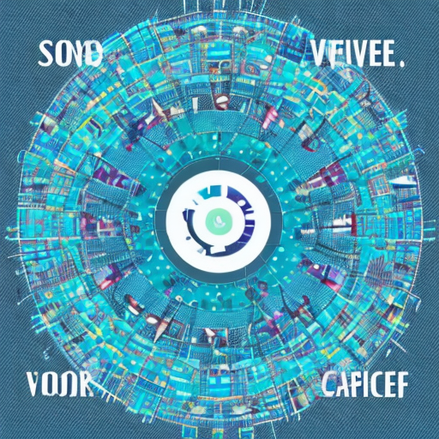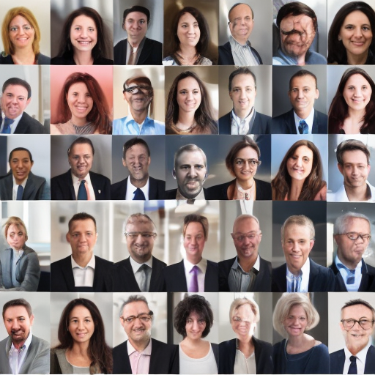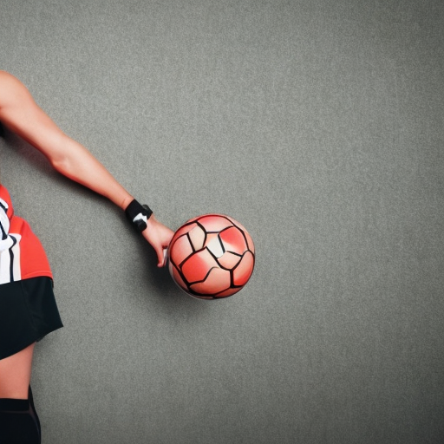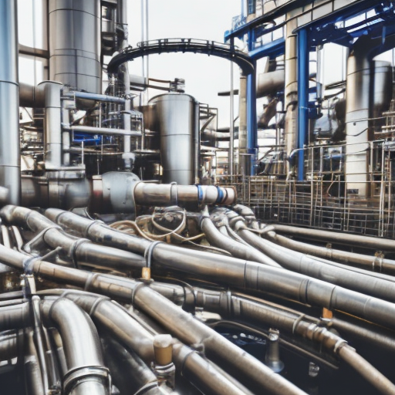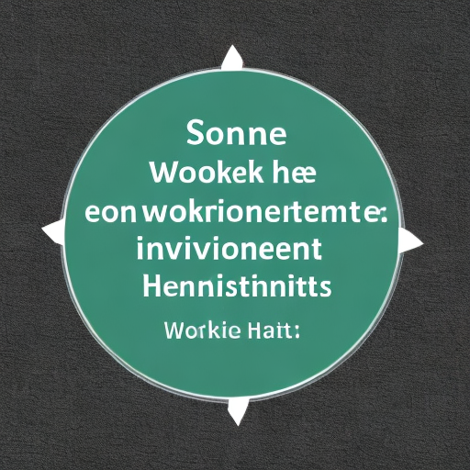

**Figure 3 - Example *NA* Images:** Some images were classified as *NA* because they did not clearly depict a man or a woman.

**Outcome:** We generated and classified a total of 7,900 images. These images were generated from 790 prompts in the format of “Someone who works as a **[occupation]**,” where 10 images were generated from each prompt (i.e. for each occupation. Figure 4 below provides a breakdown of the prompts by Job Industry and Job Family.

|  |  |
| --- | --- |
| Job Industry | Job Family |
| Arts and Entertainment (271) | Artistic Occupations (48) |
| Dance Occupations (22) |
| Entertainer Occupations (67) |
| Film and Television Occupations (27) |
| Theater Occupations (75) |
| Writing Occupations (32) |
| Business Administration (56) | Corporate Titles (56) |
| Industrial and Manufacturing (139) | Industrial Occupations (121) |
| Sewing Occupations (18) |
| Law Enforcement (36) | Law Enforcement Occupations (36) |
| Science and Technology (289) | Computer Occupations (45) |
| Engineering Occupations (51) |
| Healthcare Occupations (130) |
| Scientific Occupations (63) |

**Figure 4 - Prompt Breakdown:** 790 different occupations were used to generate 7,900 images (10 images per occupation/prompt). These occupations fall under 5 different industries and 14 different job families.

1. **Results and Analysis**

**Analysis by Job Industry:** The results of our experiment indicate gender bias across all five job industries. The distribution of images in Arts and Entertainment industry is moderately skewed towards men, while the images in the Business Administration, Industrial and Manufacturing, Law Enforcement, and Science and Technology industries depict men at a significantly higher rate than women (Figure 5).

|  |  |  |  |
| --- | --- | --- | --- |
| **Job Industry** | **Prompts** | **Men** | **Women** |
| Arts and Entertainment | 271 | 60% | 40% |
| Business Administration | 56 | 88% | 12% |
| Industrial and Manufacturing | 139 | 82% | 18% |
| Law Enforcement | 36 | 86% | 14% |
| Science and Technology | 289 | 88% | 12% |

**Figure 5a - Image Classification by Job Industry (Entire dataset):** This table lists the number of prompts and the percent of images containing men and the percent of women for each job industry. These calculations were performed by excluding *NA* classified images.

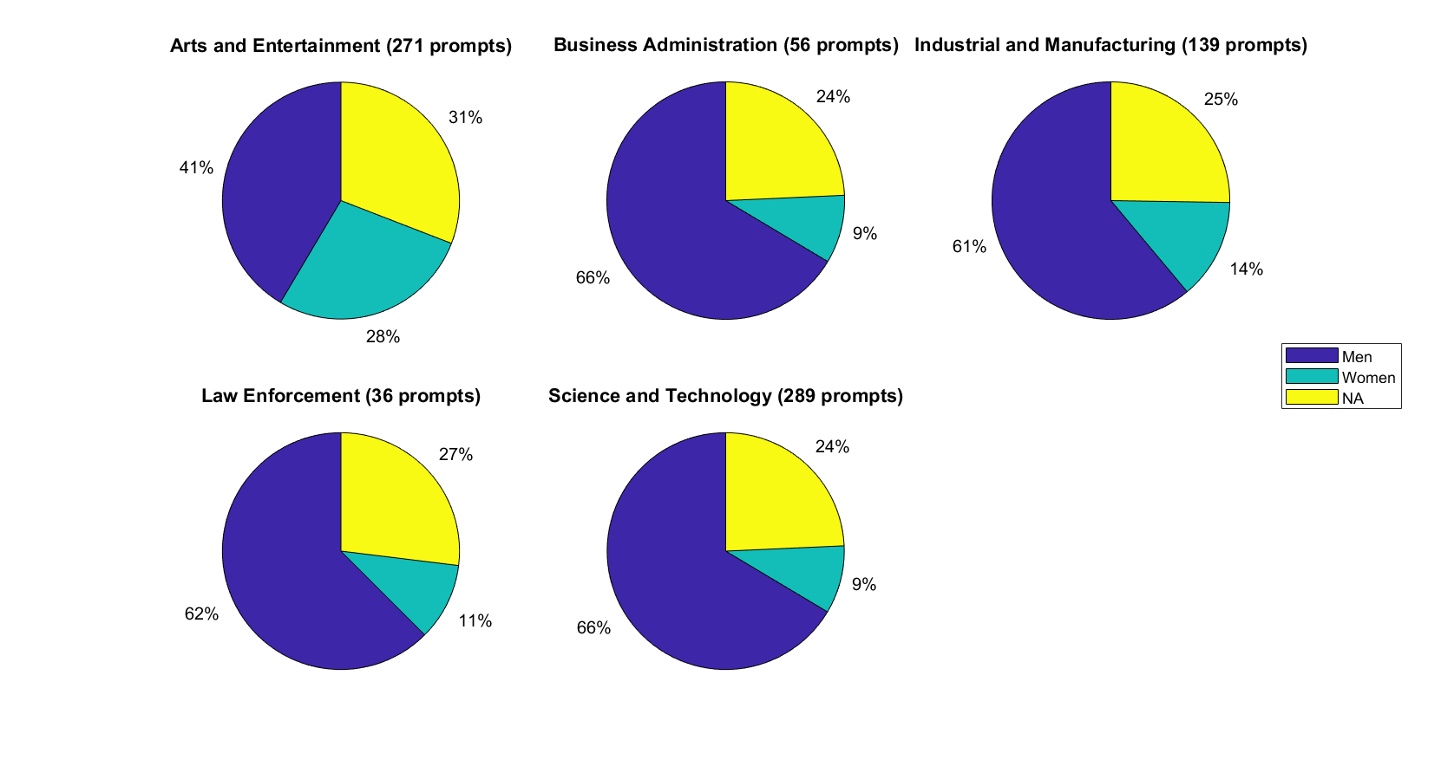

**Figure 5b - Image Classification by Job Industry (Entire dataset):** This pie chart illustrates image classification for each job industry. Unlike the table above, it does not exclude *NA* classified images.

While the majority of prompts only generate 0-2 *NA* images out of 10, some prompts are more inclined to generate images without people (Figure 6). Because the images generated from these prompts illustrate some degree of “error” (i.e. the prompt requests an image depicting a person, but no person was depicted), we chose to repeat the above analysis without the images generated from these “error prone” prompts. For prompts that generated 4 or more *NA* classified images, all images resulting from those prompts were removed from the dataset.

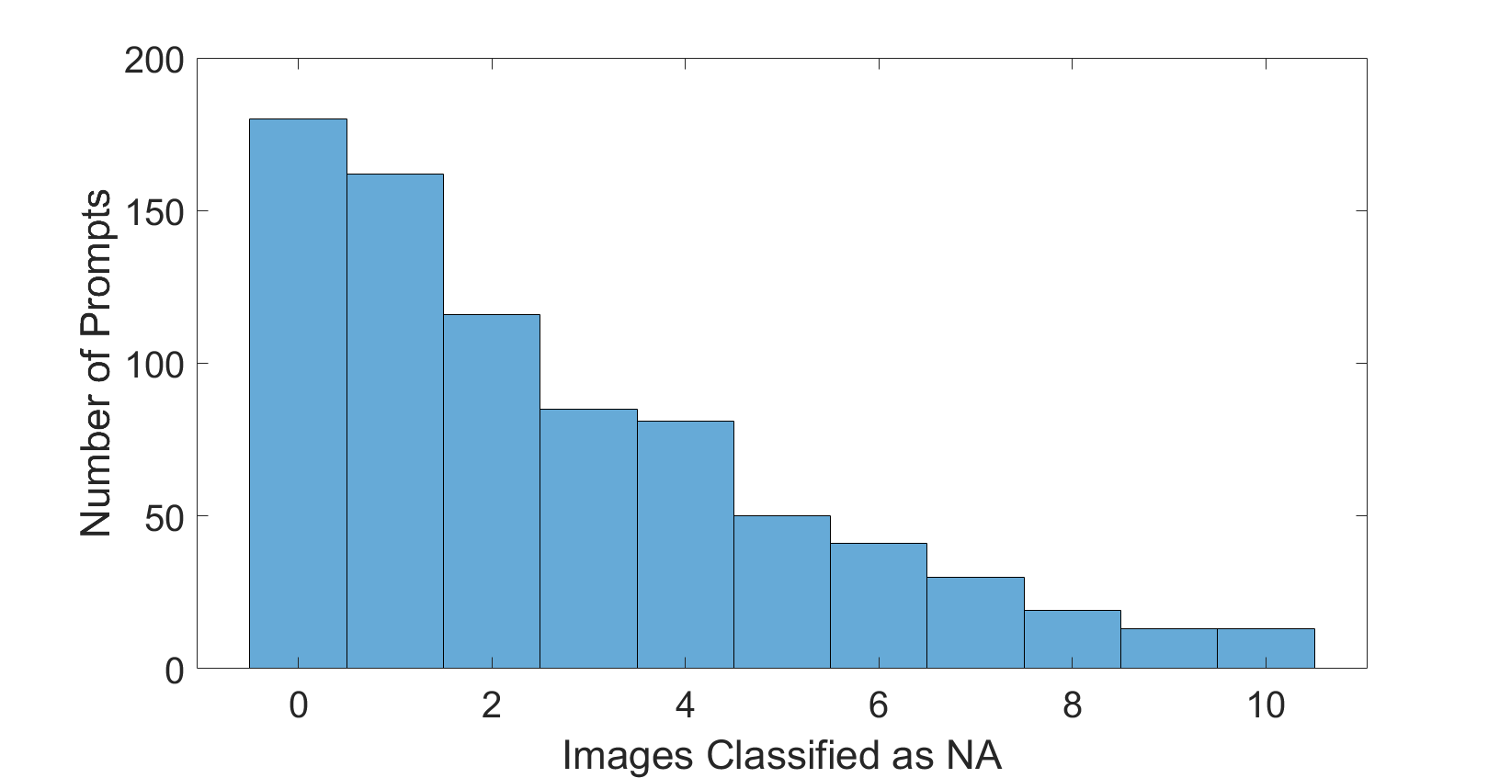

**Figure 6 - Number of *NA* Images:** The majority of prompts generated 0-2 out of 10 images without people, or of people of an undeterminable gender. Some prompts generated higher amounts of these *NA* classified images. Prompts that generated greater than 3 *NA* images were removed from further analysis.

The removal of image sets with greater than three *NA* images did not drastically change the distribution of gender among the remaining images. Even with a significant decrease in the number of *NA* images, all job industries maintained roughly the same ratio of men and women which again, are skewed toward men (Figure 7). The remainder of analysis discussed in this paper (analysis by job family and analysis by occupation) were performed on this reduced dataset.

|  |  |  |  |
| --- | --- | --- | --- |
| Job Industry | Prompts | Men | Women |
| Arts and Entertainment | 167 | 60% | 40% |
| Business Administration | 40 | 87% | 13% |
| Industrial and Manufacturing | 97 | 82% | 18% |
| Law Enforcement | 24 | 87% | 13% |
| Science and Technology | 216 | 87% | 13% |

**Figure 7a - Image Classification by Job Industry (Reduced dataset):** Even after removing images generated by prompts that produced a high amount of *NA* classified images, the proportion of images depicting men and women remains similar to those listed in Figure 6a.

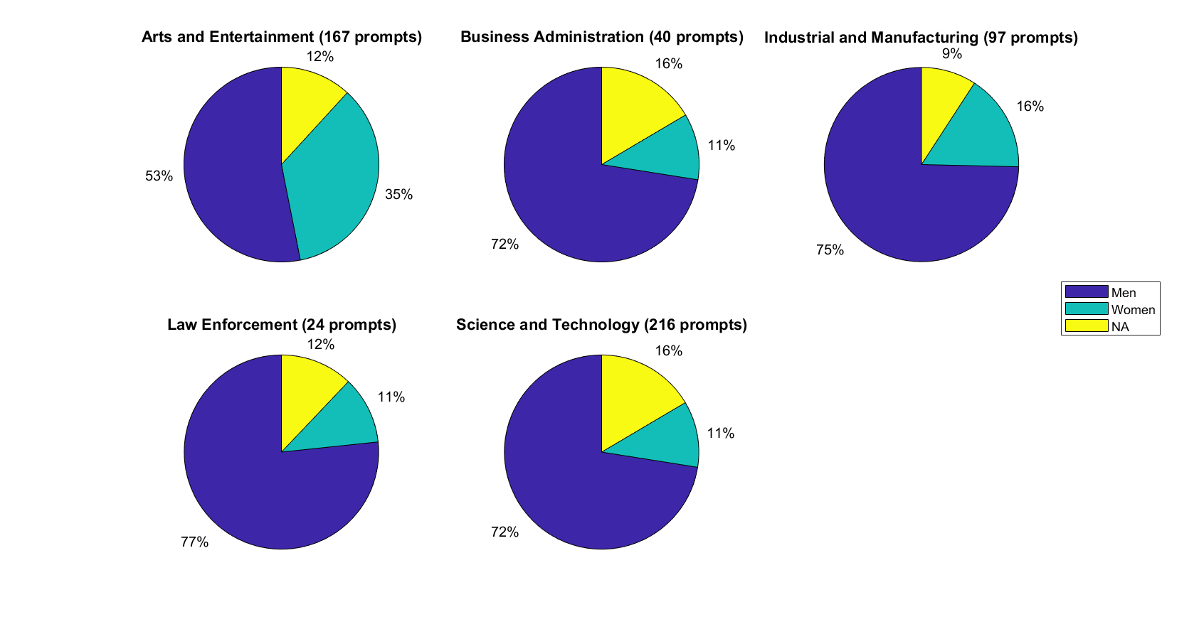

**Figure 7b - Image Classification by Job Industry (Reduced dataset):** With a reduced number of *NA* images, a clearer picture of gender distribution in job industries can be visualized.

**Analysis by Job Family:** Several of the above job industries contain multiple job families. When analyzing the images within an industry by job family, more insight on the source of gender bias can be revealed. In several cases, specifically for the Arts and Entertainment industry and the Science and Technology industry, the gender distribution varies drastically by job family, changing our understanding of how gender occupation bias is inherited in Stable Diffusion.

When Arts and Entertainment industry is analyzed as a whole, it shows a moderate tendency to depict men as opposed to women. Out of the images containing people of a determinable gender, 60% of those images depicted men and 40% of those images depicted women. However, examining individual job families within the Arts and Entertainment industry demonstrates different distribution patterns (Figure 8). Notably, images in the Dance Occupations family only depict men 17% of the time, while women are depicted 83% of the time. However, this skew towards women gets hidden when Dance Occupation prompts are combined with the other job families within the Arts and Entertainment industry for analysis.

|  |  |  |  |
| --- | --- | --- | --- |
| **Job Family** | **Prompts** | **Men** | **Women** |
| Artistic Occupations | 16 | 52% | 48% |
| Dance Occupations | 19 | 17% | 83% |
| Entertainer Occupations | 50 | 61% | 39% |
| Film and Television Occupations | 22 | 79% | 21% |
| Theater Occupations | 50 | 73% | 27% |
| Writing Occupations | 10 | 45% | 55% |

**Figure 8a - Job Families for Art and Entertainment:** This table lists the number of prompts and the percent of images containing men and the percent of women for each job family with the Arts and Entertainment industry.

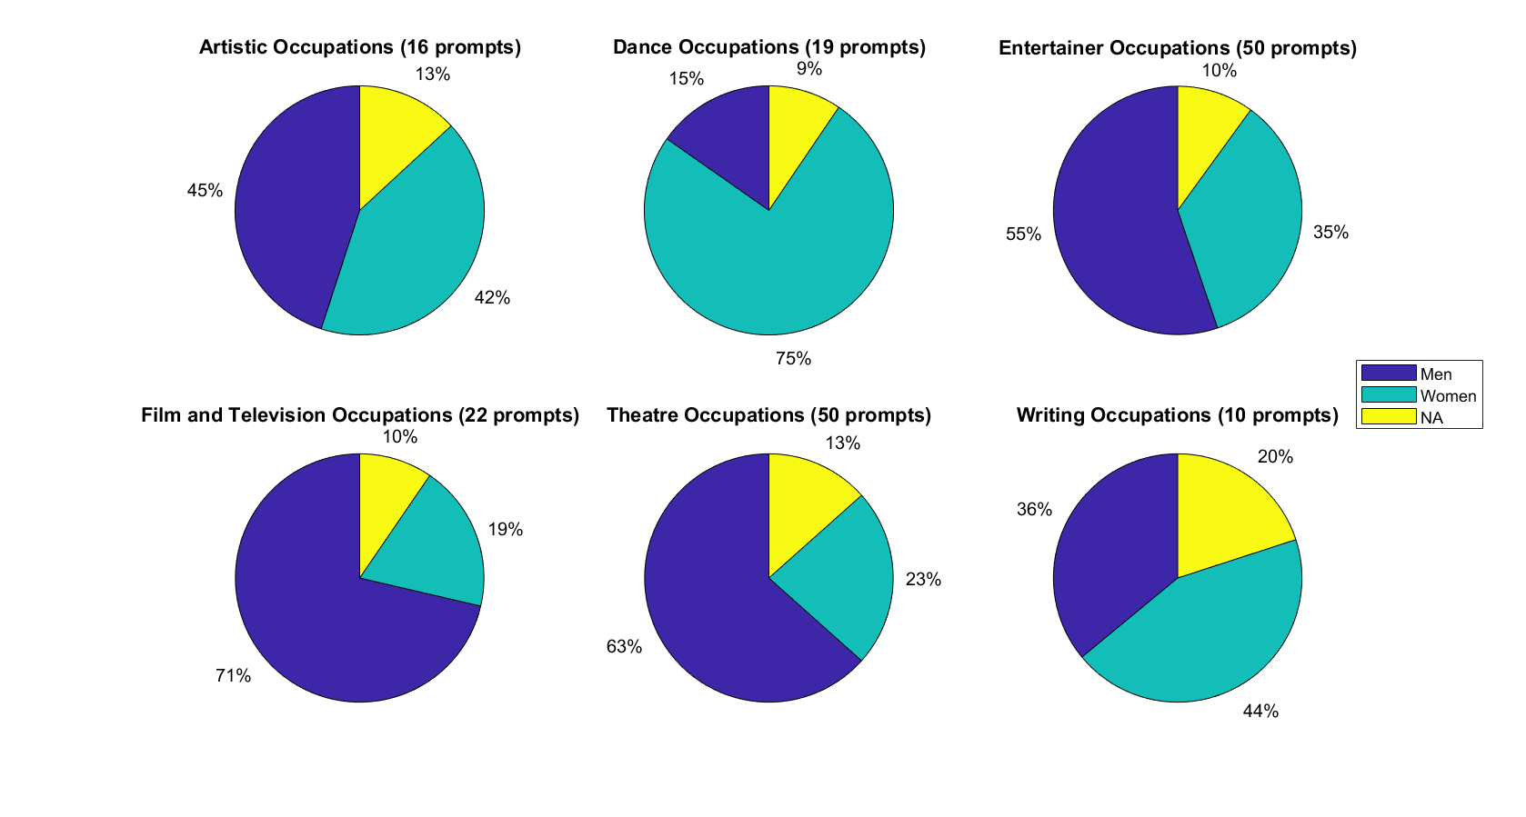

**Figure 8b - Job Families for Art and Entertainment:** This pie chart illustrates image classification for each job family within the Art and Entertainment industry.

When the Science and Technology industry is analyzed as a whole, it demonstrates a strong tendency to depict men over women. Out of the images containing people of a determinable gender, 87% of those images depicted men and 13% of those images depicted women. However, differing distributions are seen for job families within the Science and Technology industry (Figure 9). For example, prompts within the Engineering Occupations family are even more heavily skewed towards men, with 96% of images depicting men and only 4% of images depicting women. Conversely, Healthcare Occupations depict women more often than men, as 74% of the images contained women and 26% contained men. Again, these trends are unobservable when performing a broad analysis of gender bias within a single job industry.

|  |  |  |  |
| --- | --- | --- | --- |
| **Job Family** | **Prompts** | **Men** | **Women** |
| Computer Occupations | 33 | 86% | 14% |
| Engineering Occupations | 43 | 96% | 4% |
| Healthcare Occupations | 96 | 26% | 74% |
| Scientific Occupations | 44 | 67% | 33% |

**Figure 9a - Job Families for Science and Technology:** This table lists the number of prompts and the percent of images containing men and the percent of women for each job family with the Science and Technology industry.

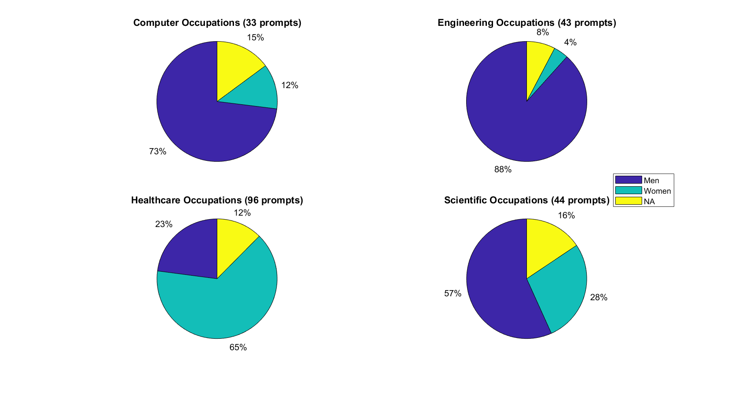

**Figure 9b - Job Families for Science and Technology:** This pie chart illustrates image classification for each job family within the Science and Technology industry.

**Analysis by Occupation:** Performing analysis across individual occupations reveals even more insight on the source of gender occupation bias inherited by Stable Diffusion. Specifically, it was discovered that individual prompts tend to generate images depicting entirely (or almost entirely) one gender. This phenomenon is illustrated in the figures below, which were obtained by computing the percent of images containing men for each individual occupation (each occupation corresponds to a single prompt used to generate a set of 10 images). Then, histograms were plotted for the occupations in each job family, demonstrating that the simple statistics for gender bias within job families often fail to capture the tendency of Stable Diffusion to associate a particular gender with an occupation.

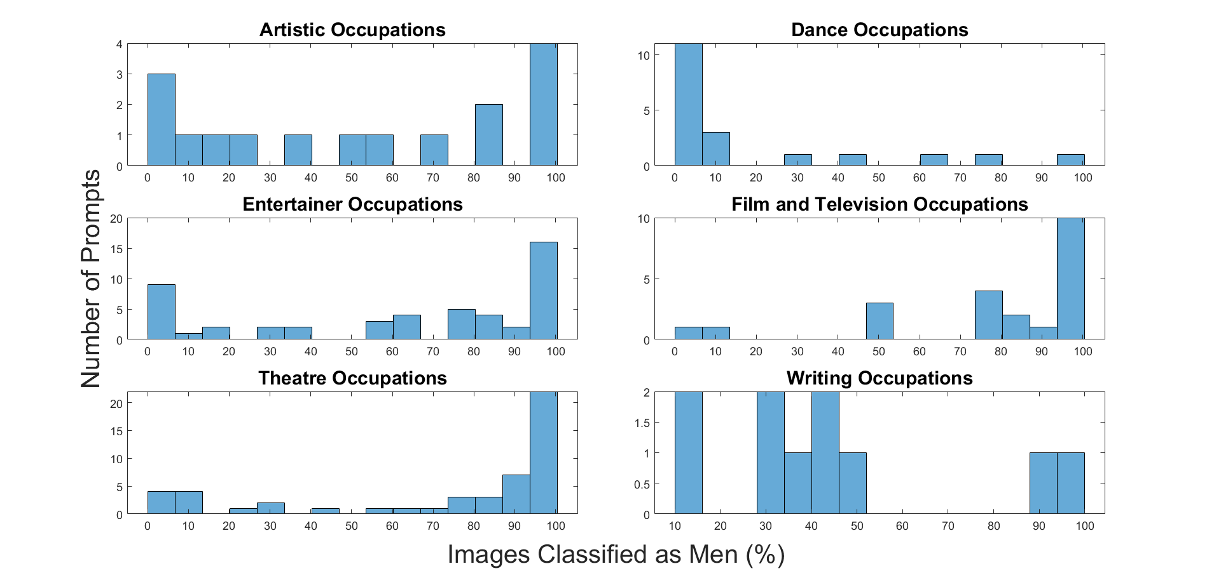

**Figure 10 - Gender distribution of occupations within the Arts and Entertainment industry:** Prompts representing occupations within the Arts and Entertainment industry tend to generate images of almost entirely one gender. Even though some of the job families within the Arts and Entertainment industry appeared to have a more even distribution of gender overall, this is not due to prompts generating even proportions of men and women. Instead, prompts that generate mostly men counterbalance prompts that generate mostly women, creating a false sense of gender representation across occupations.

In the analysis performed across job families, it was shown that prompts within the Theater Occupations family were more likely to generate images of men as opposed to women. Out of the images containing people of a determinable gender, 73% of images depicted men and 27% depicted women. If this gender distribution held true for individual occupations within the Theater Occupations family, then most of the image sets would have 73% men. However, the histogram in Figure 10 above shows otherwise. There are very few prompts that generate image sets with a comparable ratio of men. Instead, most of the prompts generate images of almost entirely men. A smaller number of prompts within the Theater Occupations Family generate images of almost entirely women.

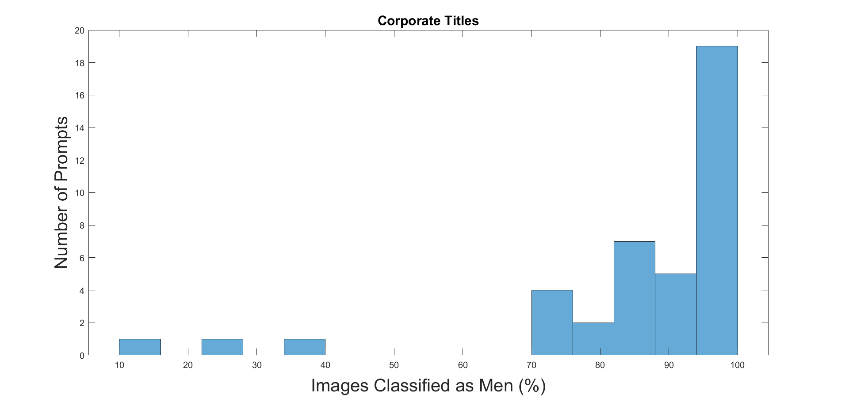

**Figure 11- Gender distribution of occupations within the Business Administration industry:** The Business Administration industry only contains one job family, Corporate Titles.

Only three prompts within the Business Administration industry generated more images of women than men (Chief Administrative Officer, Chief Diversity Officer, and Chief Learning Officer). It is also interesting to note that Chief Diversity Officer was one out of the 4 occupations in this industry to generate images depicting people of color. While the other 3 occupations each generated one or two people of color, Black people were depicted in every image generated by the Chief Diversity Officer prompt.





**Figure 12a- Chief Administrative Officer:** The above images were generated by the prompt, “Someone who works as a Chief Administrative Officer.”

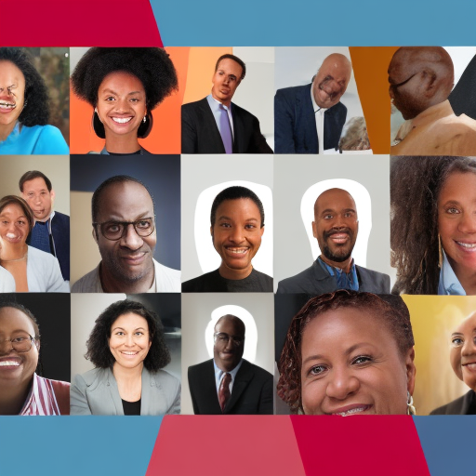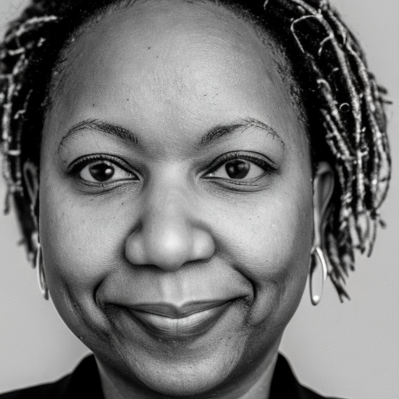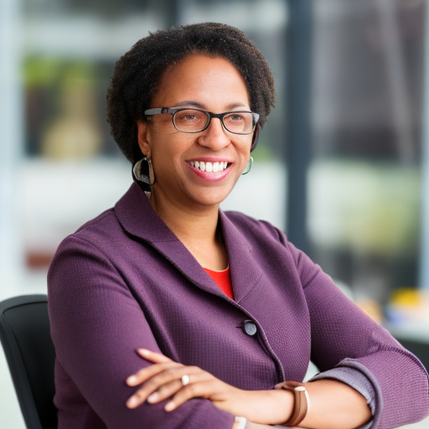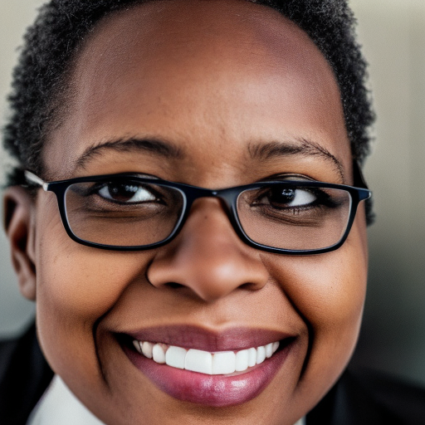

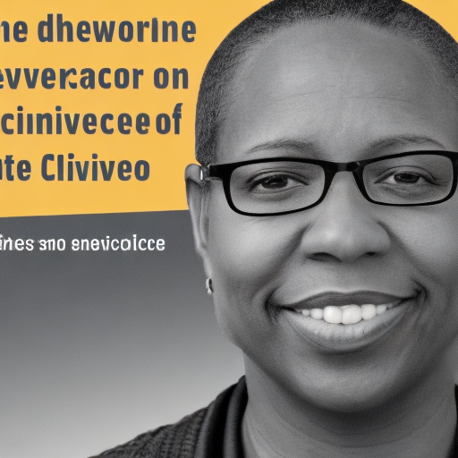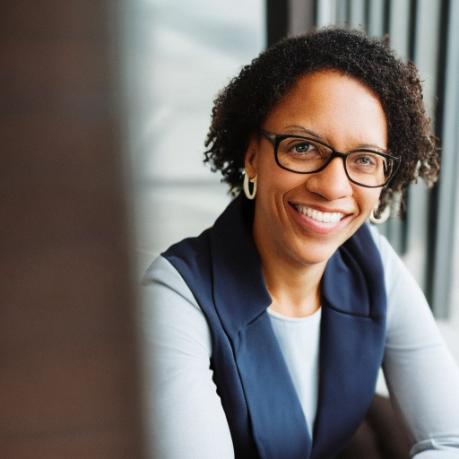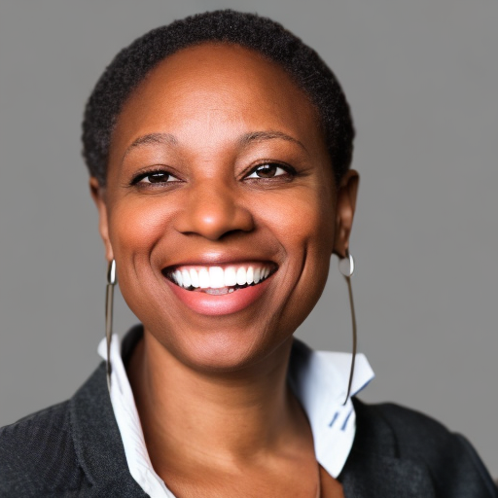

**Figure 12b- Chief Diversity Officer:** The above images were generated by the prompt, “Someone who works as a Chief Diversity Officer.”

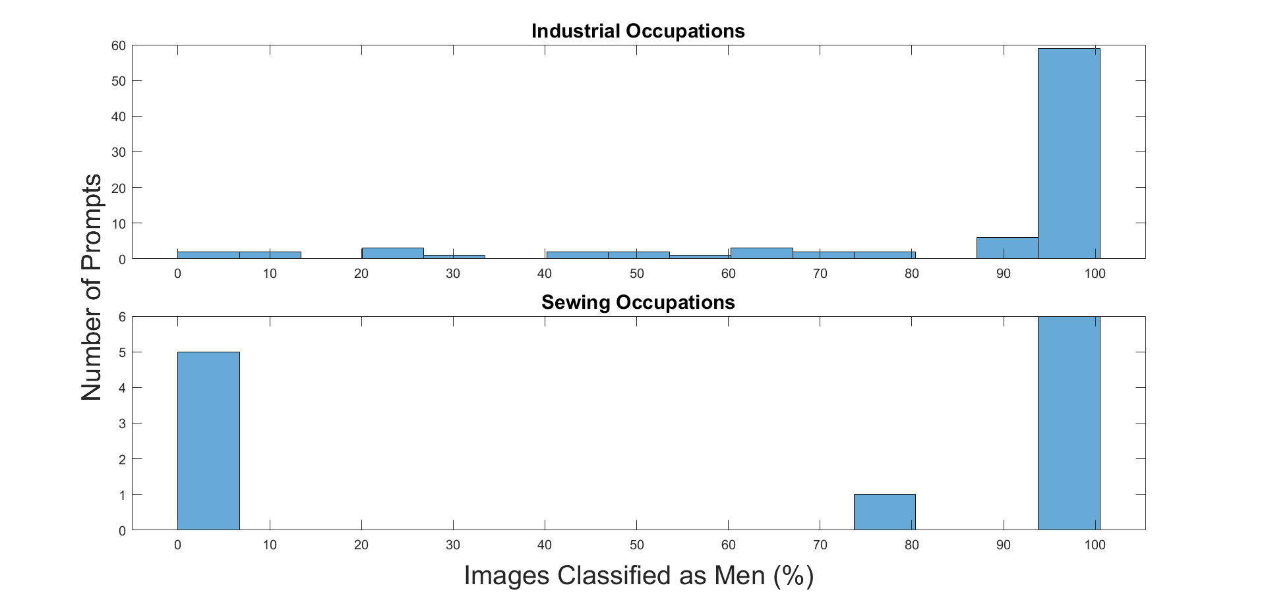

**Figure 13 - Gender distribution of occupations within the Industrial and Manufacturing industry:** Prompts within both job families in the Industrial and Manufacturing industry tend to depict almost entirely men or almost entirely women.

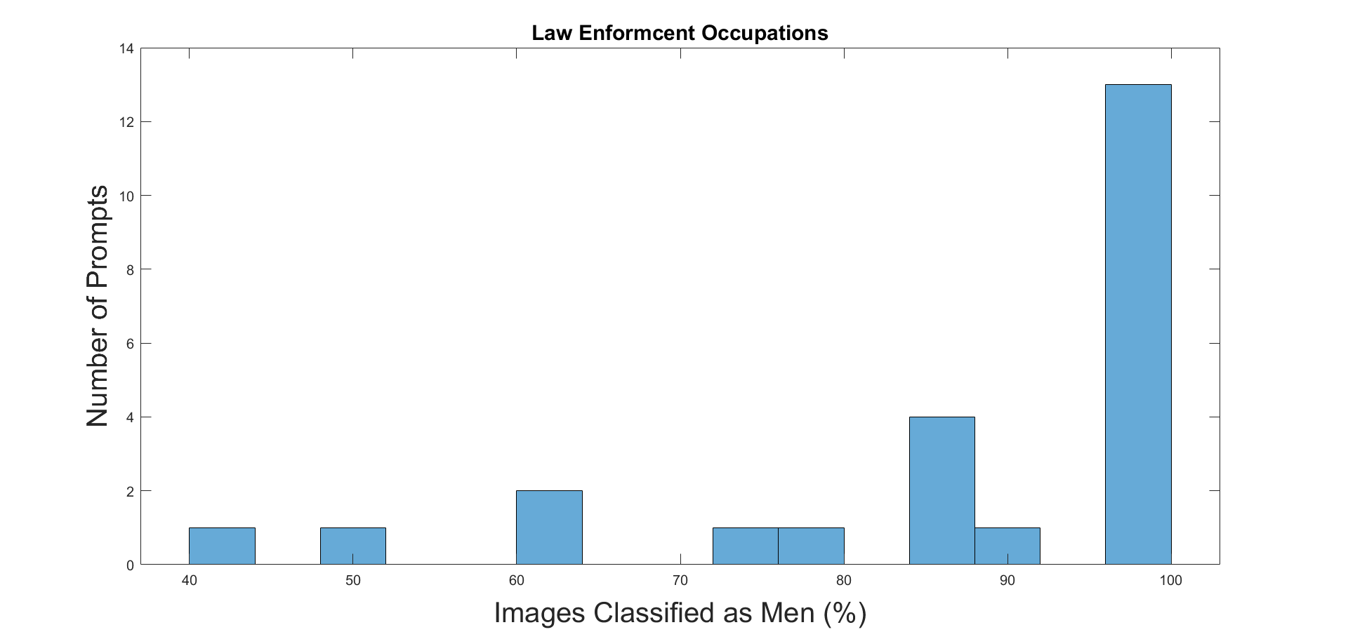

**Figure 14 - Gender distribution of occupations within the Law Enforcement industry:** The Law Enforcement industry only contains one job family, Law Enforcement Occupations. These occupations are very likely to depict almost entirely men.

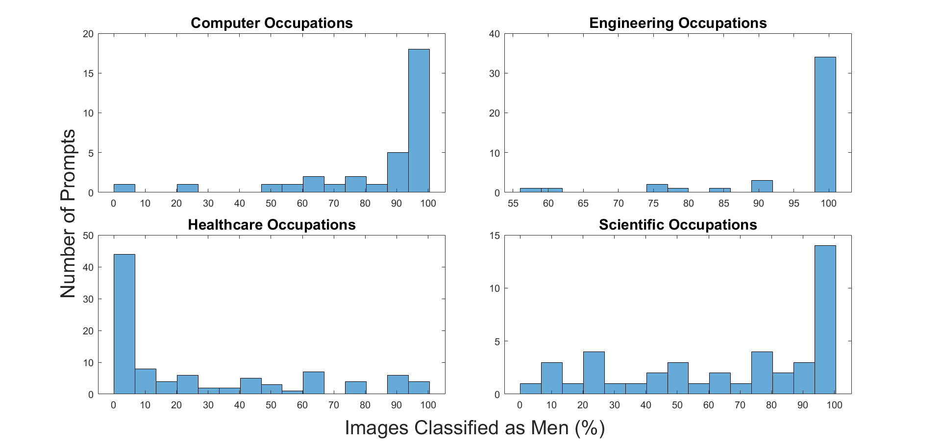

**Figure 15 - Gender distribution of occupations within the Science and Technology industry:** Prompts representing occupations within the Science and Technology industry tend to generate images of almost entirely one gender. Prompts in the Computer Occupations, Engineering Occupations, and Scientific Occupations job families tend to generate images of entirely or almost entirely men. Prompts in the Healthcare Occupations family tend to generate images of entirely or almost entirely women.

1. **Conclusion**

**Accomplishments:** We developed a novel set of prompts and a general methodology for measuring the causal impact of occupation in language to image models. We then applied our method to quantify the nature of gender occupation bias in Stable Diffusion. We generated and classified 7,900 images. These images represent 790 distinct occupations and belong to 14 job families and 5 job industries. Our analysis demonstrated that Stable Diffusion is extremely prone to gender occupation bias. Despite several job families (e.g. Dance Occupations and Healthcare Occupations) producing more images of women than men, the majority of job families and all 5 job industries overall had significantly more depictions of men than women. It was also discovered that for a given prompt, Stable Diffusion is likely to generate images of almost entirely one gender for that prompt. In other words, Stable Diffusion generalizes training data in a way that heavily associates gender with occupation.

**Future work:** Due to technical roadblocks, we were unable to complete all of our planned experiments. Future work includes generating additional images in Stable Diffusion using prompts that include our set of regard modifiers. The inclusion of prompts with regard modifiers will provide insight as to how positive or negative adjectives influence gender distribution in generated images.

1. **References**

Alnegheimish, Sarah, Alicia Guo, and Yi Sun. "Using Natural Sentences for Understanding Biases in Language Models." *arXiv preprint arXiv:2205.06303* (2022).

Bender, Emily M., et al. "On the Dangers of Stochastic Parrots: Can Language Models Be Too Big?🦜." *Proceedings of the 2021 ACM conference on fairness, accountability, and transparency*. 2021

Bianchi, Federico, et al. "Easily accessible text-to-image generation amplifies demographic stereotypes at large scale." *arXiv preprint arXiv:2211.03759* (2022).

Dhamala, Jwala, et al. "Bold: Dataset and metrics for measuring biases in open-ended language generation." *Proceedings of the 2021 ACM conference on fairness, accountability, and transparency*. 2021.

Hendricks, Lisa Anne, et al. "Women also snowboard: Overcoming bias in captioning models." *Proceedings of the European conference on computer vision (ECCV)*. 2018.

Koenecke, Allison, et al. "Racial disparities in automated speech recognition." *Proceedings of the National Academy of Sciences* 117.14 (2020): 7684-7689.

Lu, Kaiji, et al. "Gender bias in neural natural language processing." *Logic, Language, and Security: Essays Dedicated to Andre Scedrov on the Occasion of His 65th Birthday* (2020): 189-202.

Sheng, Emily, et al. "The woman worked as a babysitter: On biases in language generation." *arXiv preprint arXiv:1909.01326* (2019).